1 **SPREADSHEET PROGRAMS**

**A In pairs, discuss these questions.**

**1** What is a spreadsheet?

A spreadsheet is like a large sheet of paper with a lot of columns and rows.

**2** What are spreadsheets used for?

Spreadsheets are used in business for financial planning, to make calculations, to keep a record of the accounts.

**B Look at the worksheet and label a, b and c with column, row and cell.**

**Then answer these questions.**

**1** What types of data can be keyed into a cell?

You can enter text, numbers and formulae.

**2** What happens if you change the value of a cell?

The values of the spreadsheet are automatically recalculated.

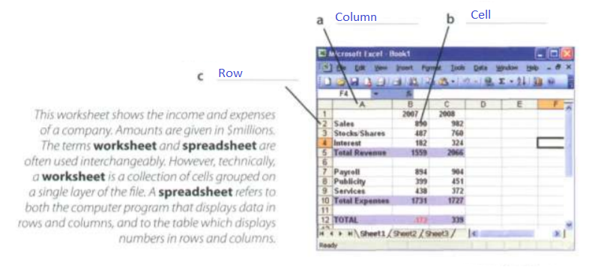

**C Listen to Lucy Boyd giving a training course on basic Excel and check your answers A and B**

**D Listen again and decide wheter these sentences are true of false. Correct the false ones.**

**1** A spreadsheet displays information in the form of a table with a lot of columns and rows.

True

**2** in a spreadsheet you can only enter numbers and formulae.

False. In a spredsheet you can enter text, numbers and formulae.

**3** You cannot change the width of columns.

False. You can change the width of columns.

**4** Spreadsheet programs can generate a variety of charts and graphs.

True

**5** Spreadsheets cannot be used as databases.

False, Spreadsheet can be used as databases.

**E Look at the worksheet above and decide whether these sentences are true or false. Correct the false ones**.

**1** The value of the cell C12 is the result of applying the formula C5-C10.

True

**2** The value of cell 85 is the result of adding the value in cells B2 and B3.

False.It’s the result of adding cells B2, B3, and B4.

**3** If you type the value 800 in C3, the value in cells CS and C12 will be recalculated.

True

2 AN INVOICE, A BUSINESS LETTER AND A FAX

**A Spreadsheets are also used to generate invoices. Complete the invoice below with words from the box. If you have a spreadsheet program, try to produce a similar invoice.**

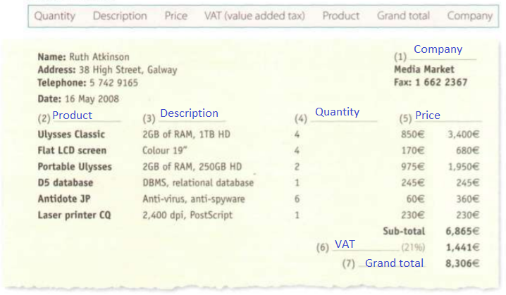

**B Look at this letter whitch accompanies the voice. Complete the letter with phrases from the box.**

Yours sincerely I am writing to Dear Ms Atkinson We would be grateful if you could I am enclosing Please contact us

16 May 2008

Ruth Atkinson

38 High Street Galway

(1) Dear Ms Atkinson

(2) I am wrinting to confirm that we have sent you four desktop PCs plus screens, two laptops and a laser printer, along with a 05 database, and an anti-virus program for each of the computers. Please allow two weeks for delivery.

(3) I am enclosing two copies of your invoice.

(4) We would be grateful if you could make your payment by cheque or directly to our bank account through the Internet_ We are also delighted to inform you that we are offering our clients an online course called A paperless office, free of charge.

(5) Please contact us if you require any further information.

(6) You sincerely

Ian Pegg

C **Imagine you are Ruth Atkinson. When you try to use the laser printer, it gives continuous error messages. You are also having problems installing the database. Write a fax to Media Market to complain. Ask for a new printer and an upgraded version of the database. Look at the Useful language box to help you.**

FAX MESSAGE

To: Media Market

Fax: 1 662 2367

From: Ruth Atkinson

Subjet: Faulty products

I am writing to complain that the new printer is not working. Indicates error messaging continuously.

I am unable database update, it indicates a new update but an error appears in the installation.

We would also accept a full refund of the cost.

Yours sincerely, Ruth Atkinson.

**3 DATABASES**

A **database** is a collection of related data, and the software used in databases to store, organize and retrieve the data is called the **database management system**. or **DBMS**. However, we often use the word database to cover both meanings. A database can manage any type of data, including text, numbers, images, sound, video and hyperlinks (links to websites).

Information is entered into the database via **fields**. Each field holds a separate piece of information, and the fields are grouped together in **records**. Therefore, a record about an employee might consist of several fields which give their name, address, phone number, date of birth. salary and length of employment with the company.

Records are grouped together into **files** which hold large amounts of information. Files can easily be **updated** -you can always change fields, add new records or delete old ones. An electronic database Is much faster to consult and update than a card index system and occupies a lot less space. With the right software, you can keep track of stock, sales, market trends, orders and other information that can help your company stay successful.

A database program lets you create an **index** - a list of records ordered according to the content of certain fields. This helps you to **search** the database and **sort**

records into numerical or alphabetical order very quickly. Modern databases are **relational** - that is, they are made up of related files: customers and orders, vendors and purchases, students and tutors, etc.Two database files can be related as long as they have a common field. A file of students, for example, could include a field called Tutor ID and another file with details of the tutors could include the same field. This key field can be used to relate the two files. Databases like Oracle, DB2 and MySQL can manage these relationships.

A database **query** function allows you to extract information according to certain conditions or criteria. For example, if a managing director wanted to know all the customers that spend more than E8,000 per month, the program would search on the name field and the money field simultaneously.

The best database packages also Include **network** facilities, which can make businesses more productive. For example, managers of different departments can have direct access to a common database. Most aspects of the program can be protected by user-defined passwords and other **security devices.** For example, if you wanted to share an employee's personal details but not their commission, you could protect the commission field.

**D Complete these statements about databases using information from the text.**

1 A database management system is used to store, organize and retrieve information from a database

2 Information is entered into a database via fields

3 Each field holds a separate piece of information.

4 Updating a file means making changes, adding new records or deleting old ones.

5 Some advantages of a database program over a manual filing system are: it is much faster to cosult it occupies much less space, records can be easily sorted. Information can be easily updated,computer databases cab shared by a lot of used over a network.

6 Access to a common database a network can be protected by using user-defined passwords and other security devices.

**E Solve the clues and complete the puzzle.**

1 A collection of data stored in a PC in a systematic way.

Database

2 A unit of a database file made up of related fields.

Record

3 A single piece of information in a record.

Field

4 A database maintains separate, related files, but combines data elements from the files for queries and reports.

Relational

5 Some companies have several computers sharing a database over a

network

6 To look for specific information, for example the name of an employee.

Search

7 To classify records into numerical or alphabetical order.

Sort

8 A tool that allows you to extract information that meets certain criteria.

Query